**CREATING ELB & AUTOSCALING USING TERRAFORM**

**STEP 1:**

Creating Terraform Machine and Attach IAM Role to the Machine.

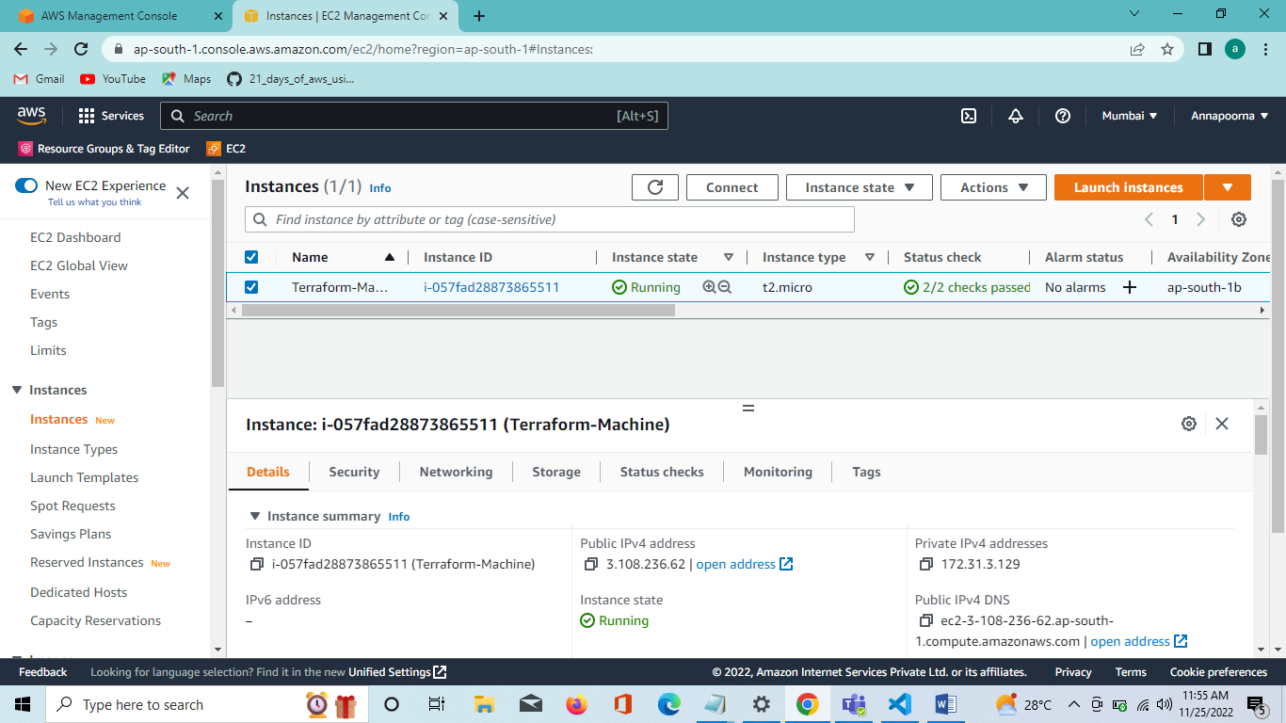

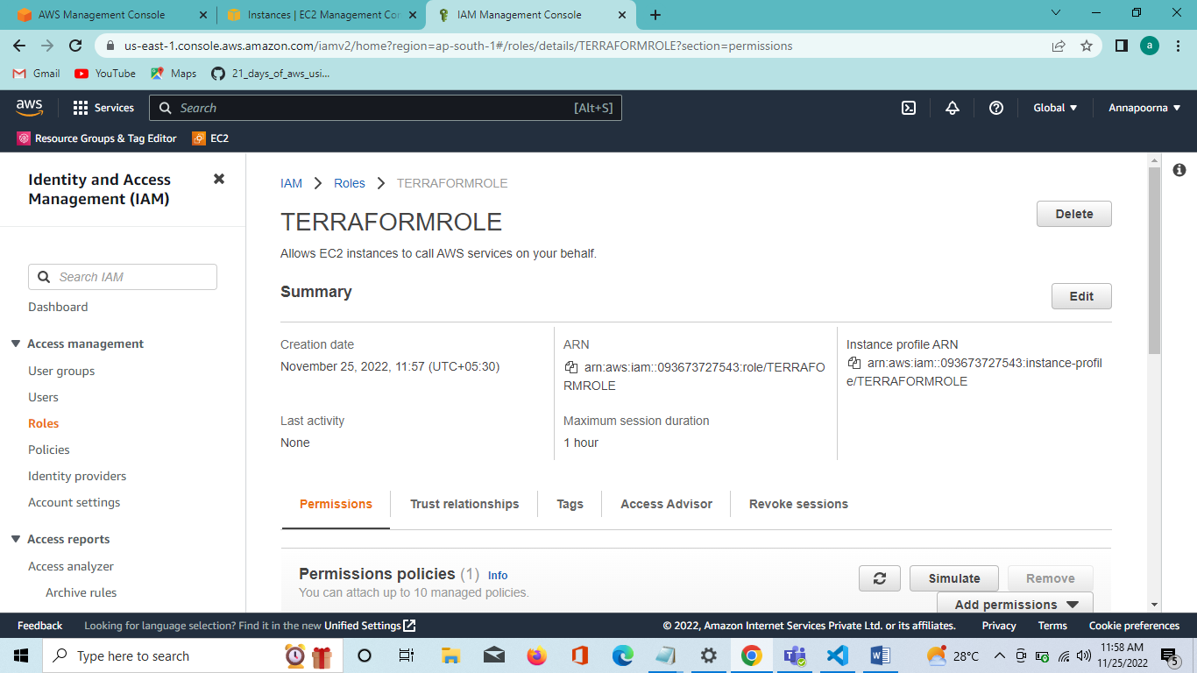

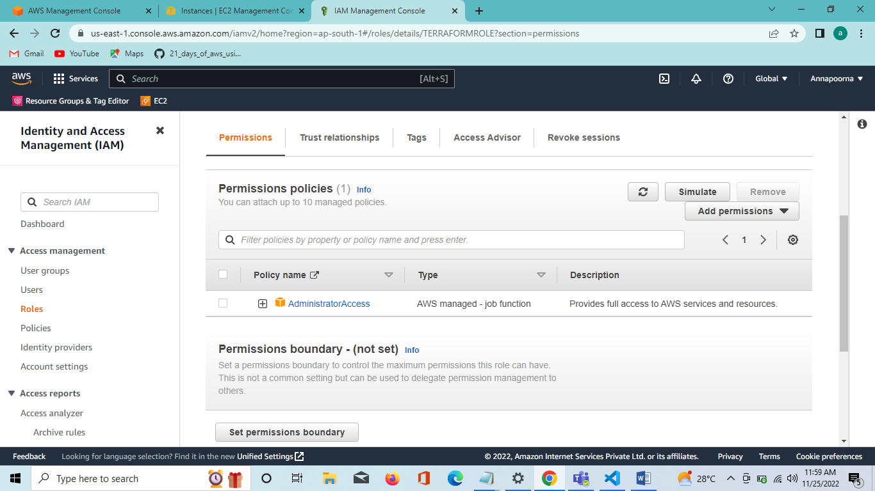

**STEP2:**

Attach IAM Role to Terraform EC2 Instance

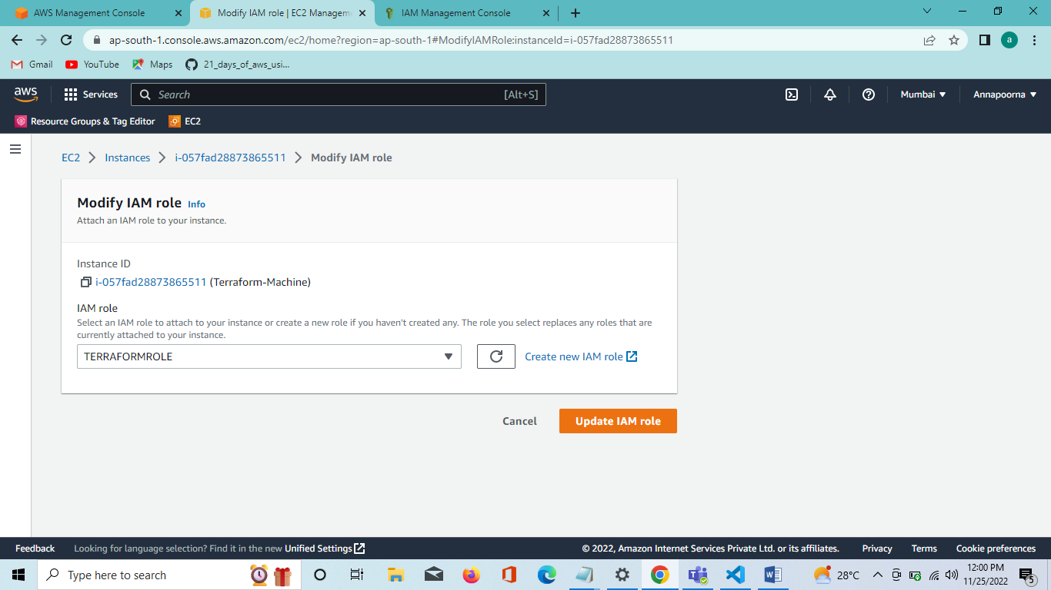

**STEP 3:**

Install TERRAFORM in LINUX Terminal.

sudo yum install -y yum-utils shadow-utils

sudo yum-config-manager --add-repo https://rpm.releases.hashicorp.com/AmazonLinux/hashicorp.repo

sudo yum -y install terraform

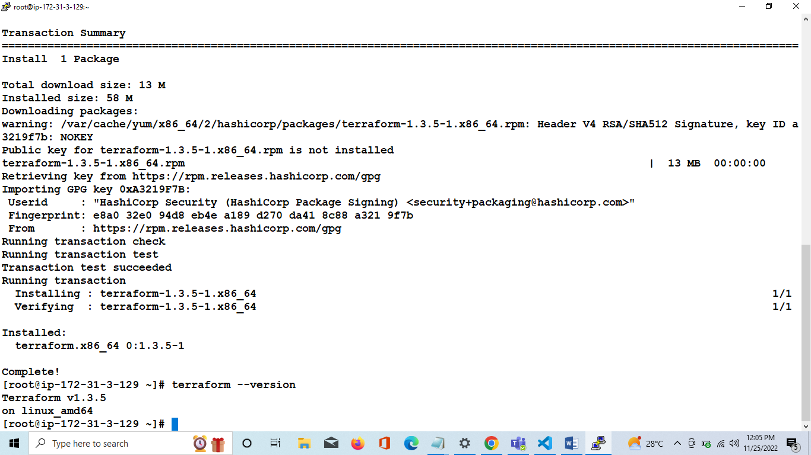

**STEP 4:**

Create VPC Using TERRAFORM

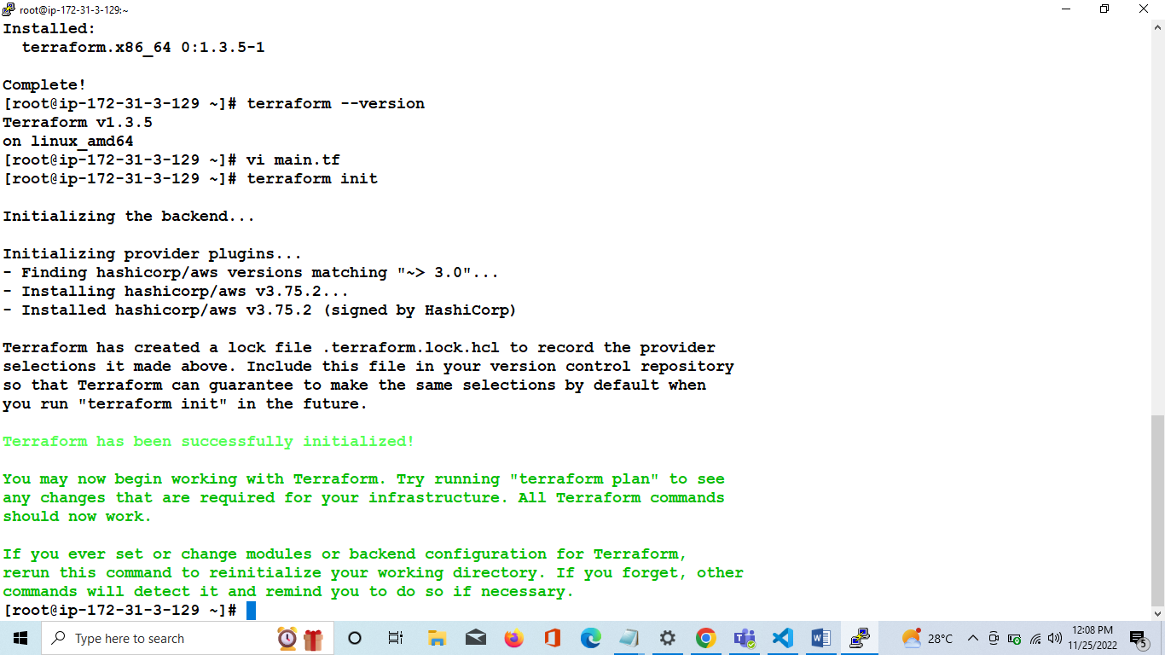

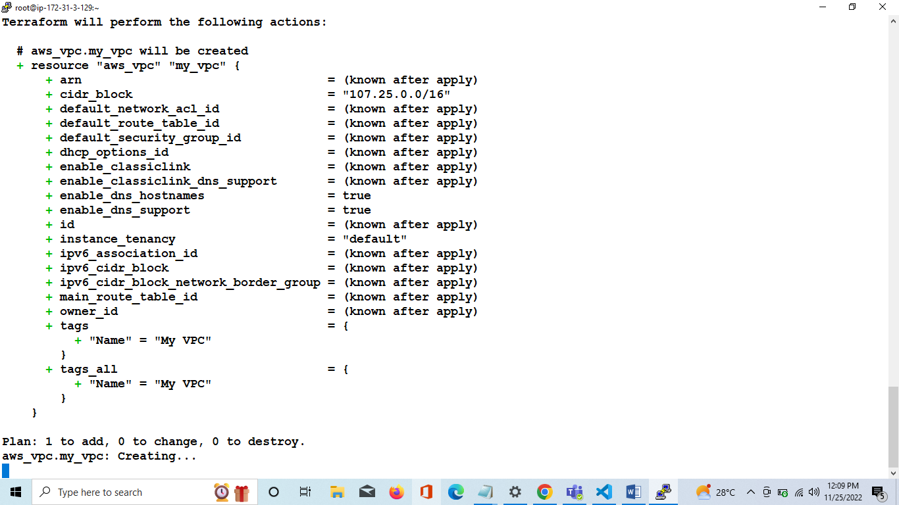

**STEP 5:**

Creating two subnets , Internet Gateway, Route Table and Subnet Association using Terraform.

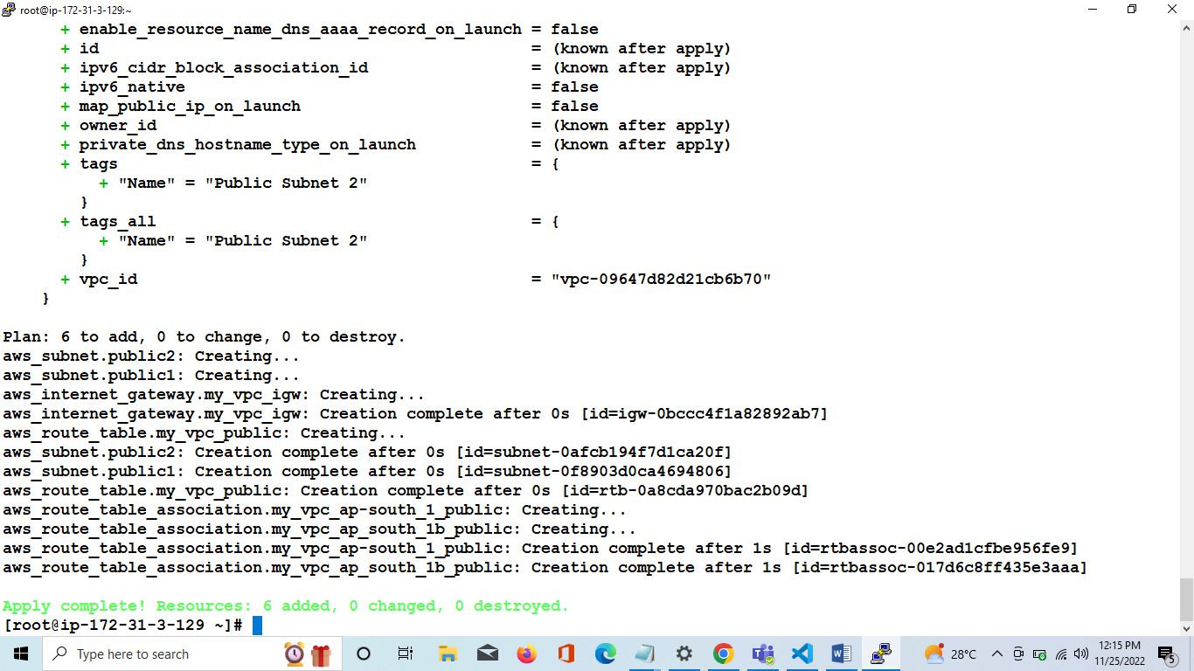

**STEP 6:**

Creating Security Group.

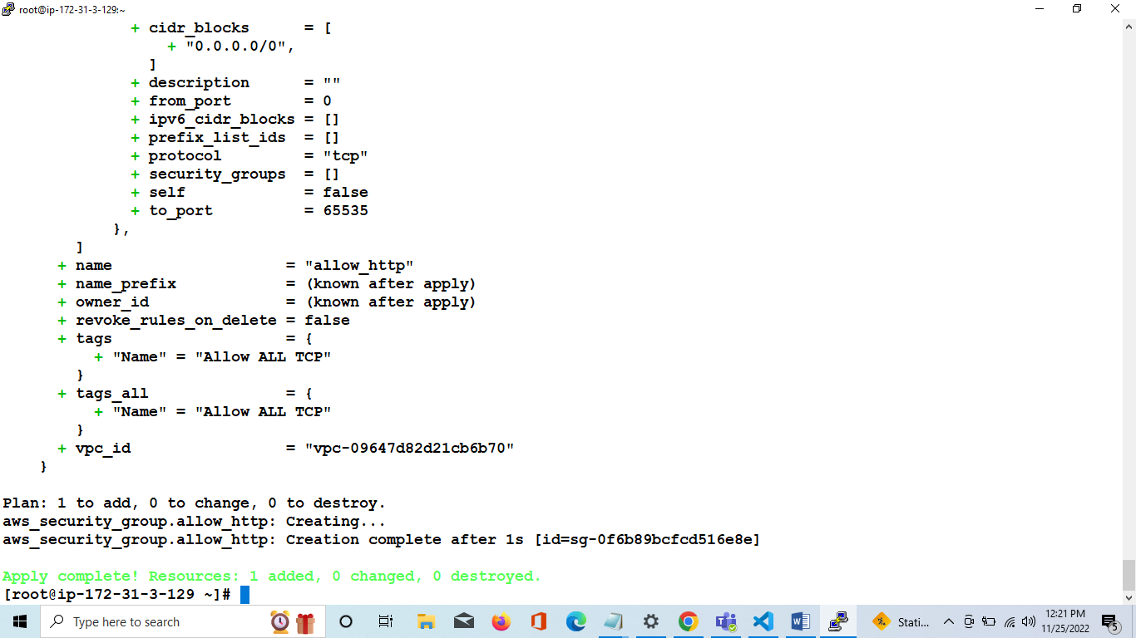

**STEP 7:**

Creating Launch Configuration and User data

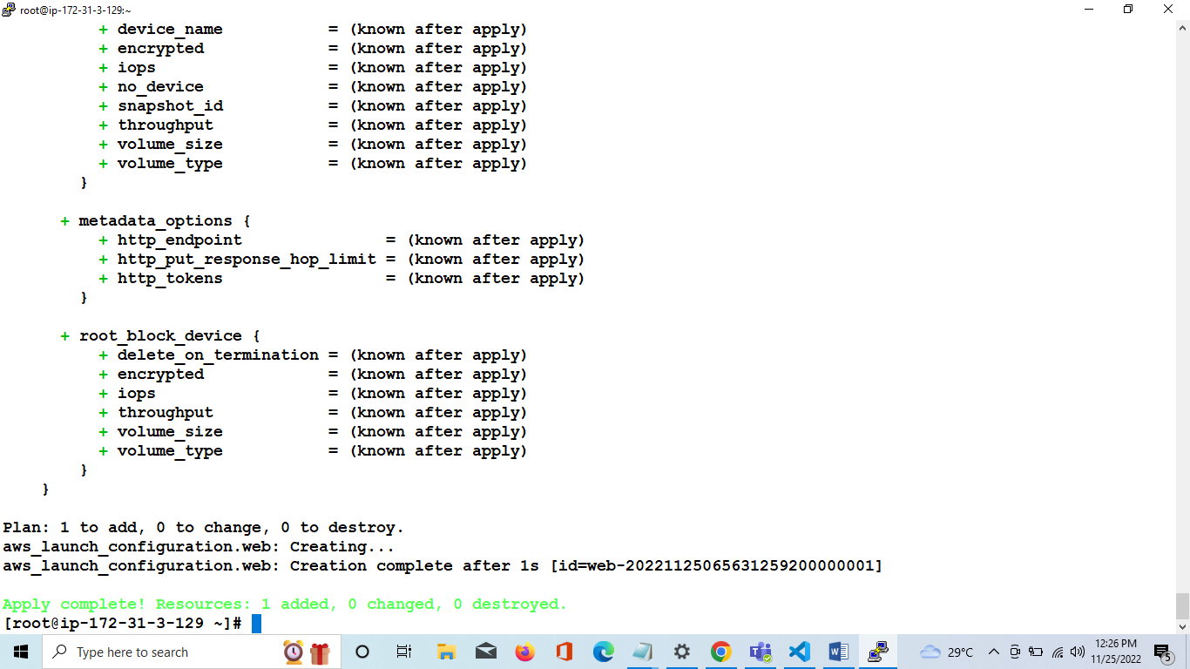

**STEP 8:**

Creating Load Balancer and Security Group for Load Balancer –

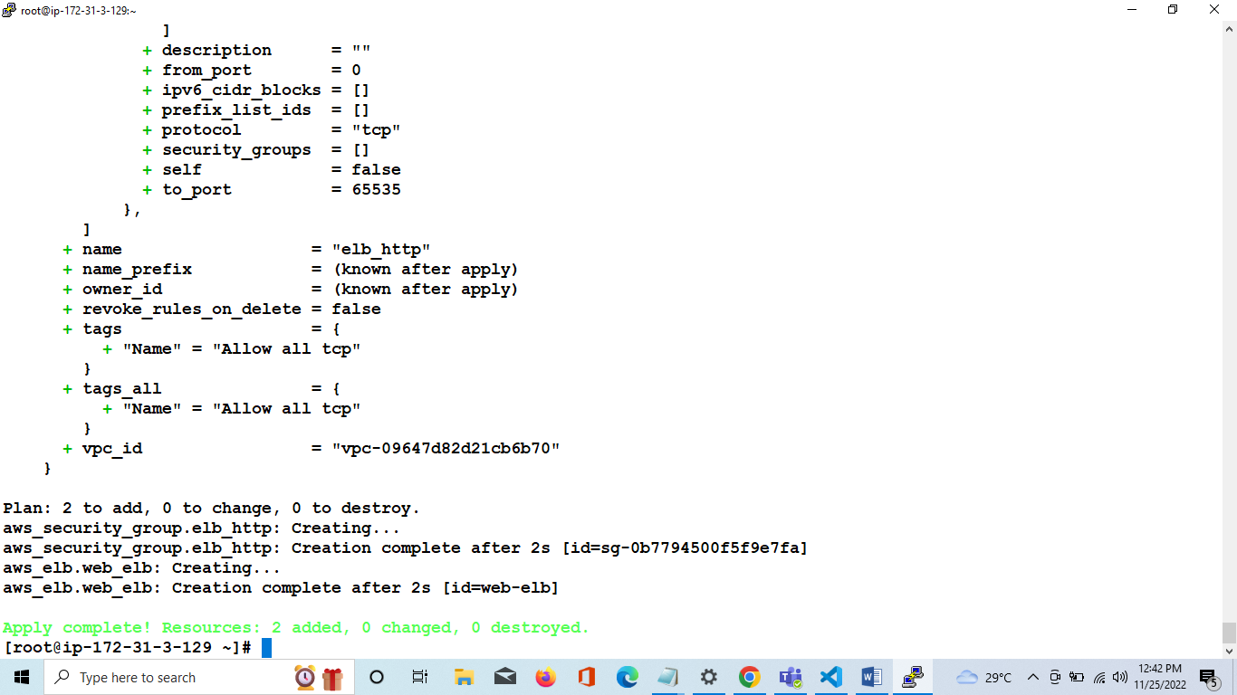

**Step 9:**

Creating AutoScaling Group and output dns name

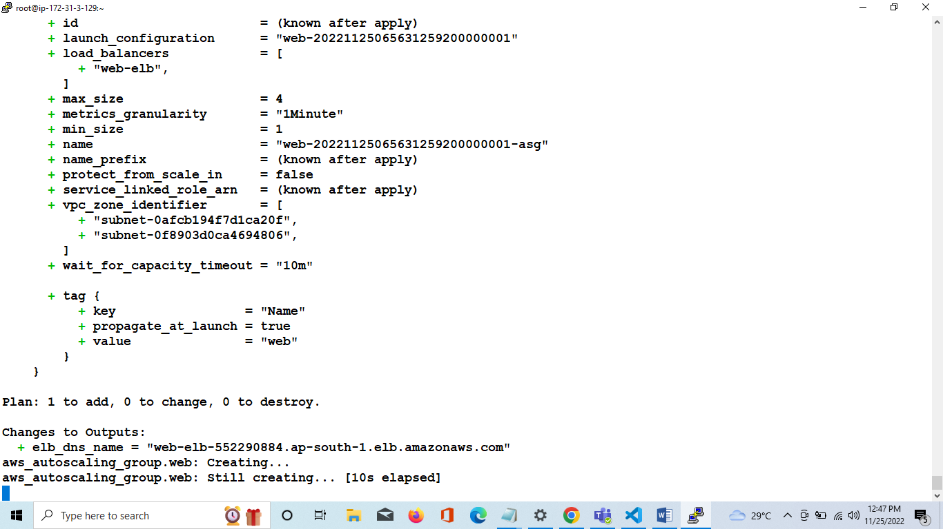

**Step 10:**

Hit the load balancer dns for Output -

